DEFA14A 1 tm2135585d2_defa14a.htm DEFA14A

UNITED STATES
SECURITIES AND EXCHANGE COMMISSION
Washington, D.C. 20549

SCHEDULE 14A

Proxy Statement Pursuant to Section 14(a) of the Securities Exchange Act of 1934 (Amendment No. )

Filed by the Registrant x
Filed by a Party other than the Registrant o
Check the appropriate box:
- Preliminary Proxy Statement o Confidential, for Use of the Commission Only (as permitted by Rule 14a-6(e)(2)) o Definitive Proxy Statement x Definitive Additional Materials
- Soliciting Material under §240.14a-12

VAREX IMAGING CORPORATION

(Name of Registrant as Specified In Its Charter) (Name of Person(s) Filing Proxy Statement, if other than the Registrant)
Payment of Filing Fee (Check the appropriate box):
x No fee required.
- Fee computed on table below per Exchange Act Rules 14a-6(i)(1) and 0-11.
  - Title of each class of securities to which transaction applies:

  - Aggregate number of securities to which transaction applies:

  - Per unit price or other underlying value of transaction computed pursuant to Exchange Act Rule 0-11 (set forth the amount on which the filing fee is calculated and state how it was determined):

  - Proposed maximum aggregate value of transaction:

  - Total fee paid:

- Fee paid previously with preliminary materials.
- Check box if any part of the fee is offset as provided by Exchange Act Rule 0-11(a)(2) and identify the filing for which the offsetting fee was paid previously.
Identify the previous filing by registration statement number, or the Form or Schedule and the date of its filing.
  - Amount Previously Paid:

  - Form, Schedule or Registration Statement No.:

  - Filing Party:

  - Date Filed:

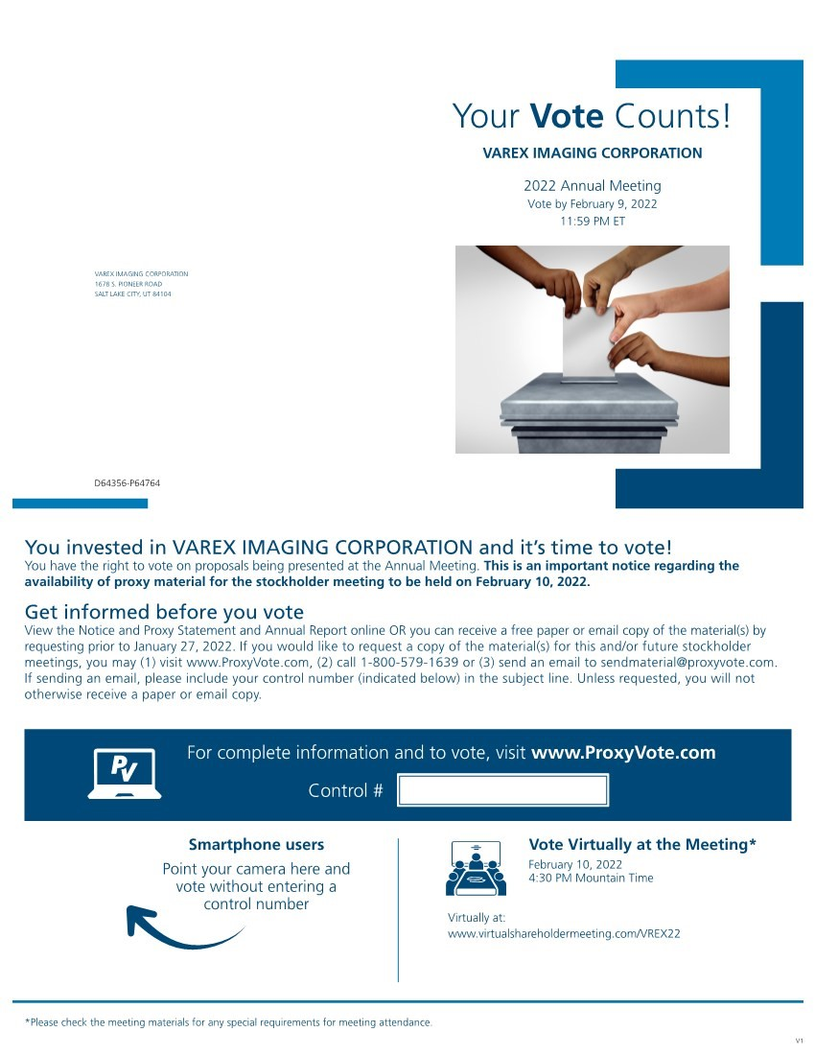
Your Vote Counts! VAREX IMAGING
CORPORATION 1678 S. PIONEER ROAD SALT LAKE CITY, UT 84104 VAREX
IMAGING CORPORATION 2022 Annual
Meeting Vote by February 9, 2022 11:59 PM ET You invested in VAREX IMAGING CORPORATION and it’s time to vote! You have the right to vote on proposals being presented at the Annual Meeting. This is an important notice regarding the availability of proxy material for the stockholder meeting to be held on February 10, 2022. Vote Virtually at the Meeting* February 10, 2022 4:30 PM Mountain Time Virtually at:
www.virtualshareholdermeeting.com/VREX22 *Please check the meeting materials for any special requirements for meeting attendance. Smartphone users Point your camera here and vote without entering a control number V1 For complete information and to vote, visit www.ProxyVote.com Control # D64356P64764 Get informed before you vote View the Notice and Proxy Statement and Annual Report online OR you can receive a free paper or email copy of the material(s) by requesting prior to January 27, 2022. If you would like to request a copy of the material(s) for this and/or future stockholder meetings, you may (1) visit www.ProxyVote.com, (2) call 1-800-579-1639 or (3) send an email to sendmaterial@proxyvote.com. If sending an email, please include your control number (indicated below) in the subject line. Unless requested, you will not otherwise receive a paper or email copy.
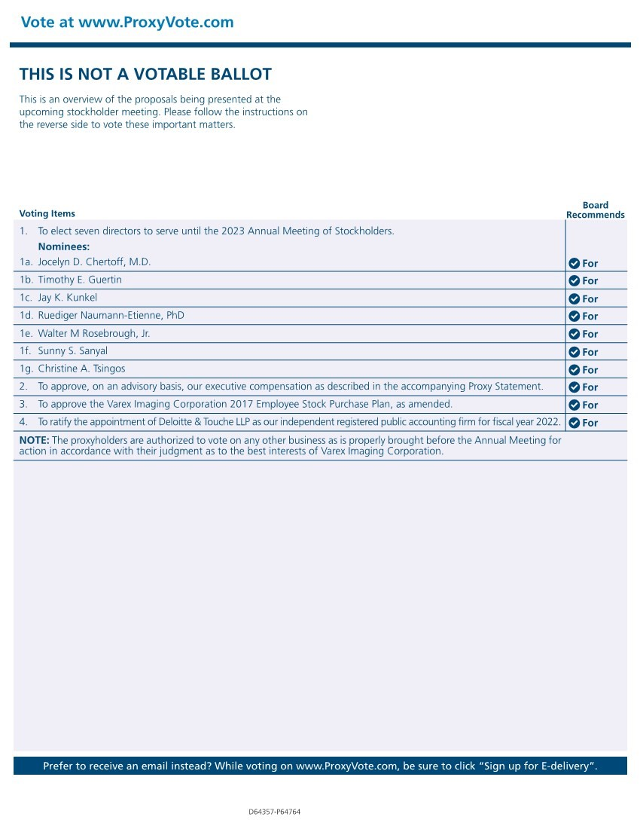
THIS IS NOT A VOTABLE BALLOT This is an overview of the proposals being presented at the upcoming stockholder meeting. Please follow the instructions on the reverse side to vote these important matters. Vote at www.ProxyVote.com Prefer to receive an email instead? While voting on www.ProxyVote.com, be sure to click “Sign up for E-delivery”. Voting Items Board
Recommends D64357-P64764
1. To elect seven directors to serve until the 2023 Annual Meeting of Stockholders.
Nominees: 1c. Jay K. Kunkel 1a. Jocelyn D. Chertoff, M.D. 1d. Ruediger Naumann-Etienne, PhD 1b. Timothy E. Guertin 1e. Walter M Rosebrough, Jr. 1f.
Sunny S. Sanyal 1g. Christine A. Tsingos 2. To approve, on an advisory basis, our executive compensation as described in the accompanying Proxy Statement. 3. To approve the
Varex Imaging Corporation 2017 Employee Stock Purchase Plan, as amended. 4. To ratify the appointment of Deloitte & Touche LLP as our independent registered public accounting firm for fiscal year 2022. NOTE: The proxyholders are authorized to vote on any other business as is properly brought before the Annual Meeting for action in accordance with their judgment as to the best interests of Varex Imaging Corporation. For For For For For For For For For For

