SEC Form 4
FORM 4 UNITED STATES SECURITIES AND EXCHANGE COMMISSION
Washington, D.C. 20549
Check this box if no longer subject to STATEMENT OF CHANGES IN BENEFICIAL OWNERSHIP
Section 16. Form 4 or Form 5obligations may continue. See
Instruction 1(b). Filed pursuant to Section 16(a) of the Securities Exchange Act of 1934
or Section 30(h) of the Investment Company Act of 1940

OMB APPROVAL
OMB Number: 3235-0287
Estimated average burden
hours per response: 0.5

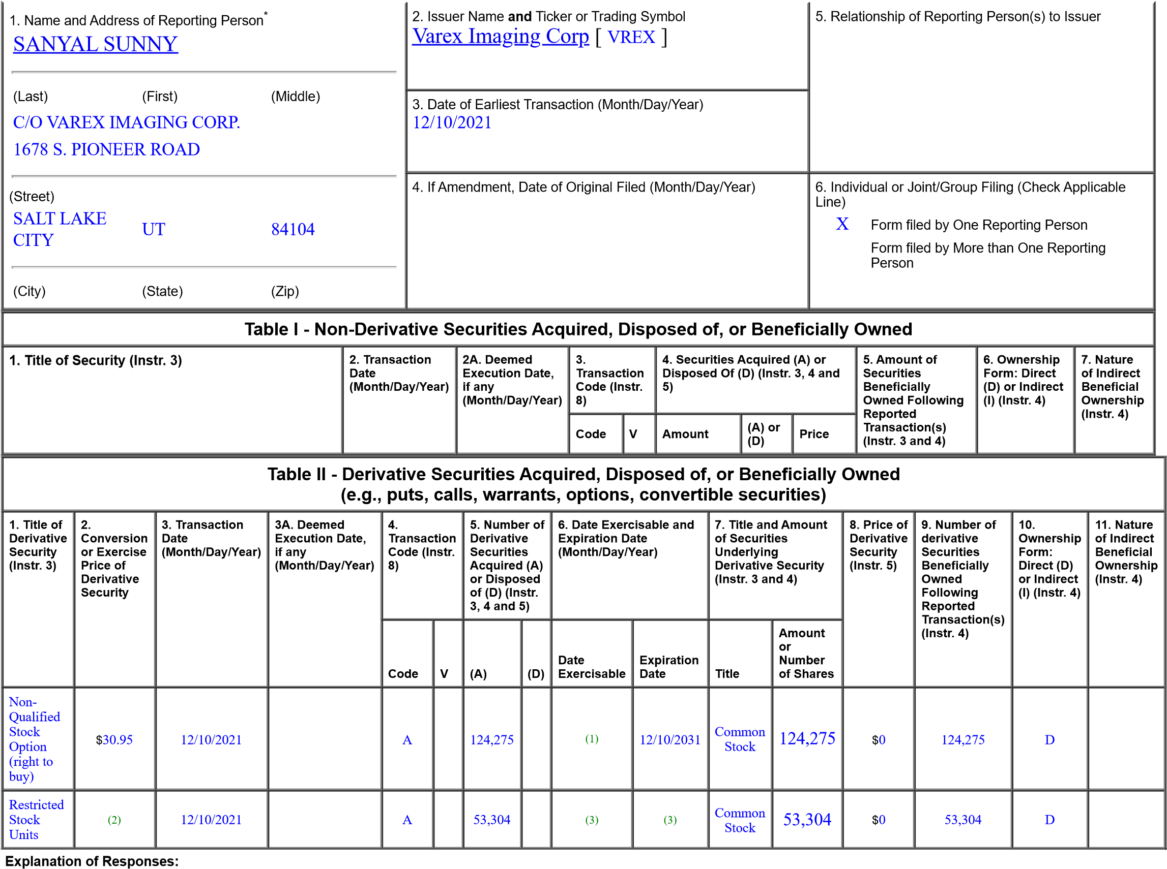
(Check all applicable)
X Director 10% Owner
_{X} Officer (give titlebelow) Other (specifybelow)
President and CEO
- These Performance Stock Options are subject to a four-year vesting schedule. 25% of the total number of options vest one year from grant date, and the remaining options vest monthly thereafter on a pro ratabasis.
- Each Restricted Stock Unit converts into common stock on a one-for-one basis.
- These Restricted Stock Units granted on December 10, 2021 vest 50% on December 10, 2023 and 50% on December 10, 2025. Vested shares will be delivered to the reporting person upon vest date.
Remarks:
/s/ Sunny Sanyal 12/14/2021
** Signature of Reporting Person Date
Reminder: Report on a separate line for each class of securities beneficially owned directly or indirectly.
* If the form is filed by more than one reporting person, see Instruction 4 (b)(v).
** Intentional misstatements or omissions of facts constitute Federal Criminal Violations See 18 U.S.C. 1001 and 15 U.S.C. 78ff(a).
Note: File three copies of this Form, one of which must be manually signed. If space is insufficient, see Instruction 6 for procedure.
Persons who respond to the collection of information contained in this form are not required to respond unless the form displays a currently valid OMB Number.

