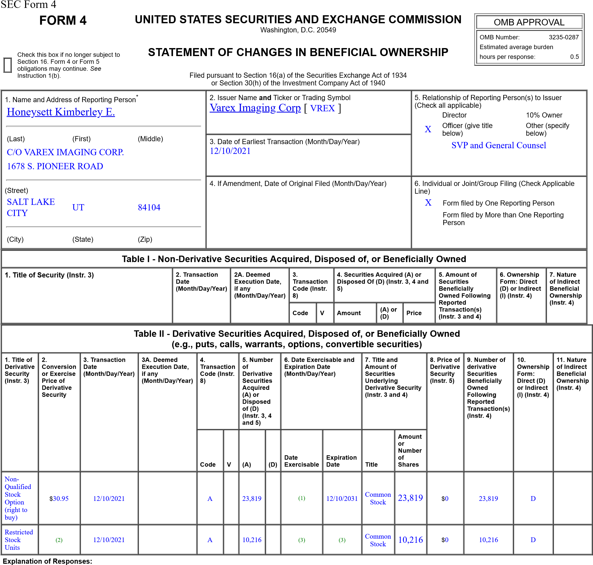
- These Performance Stock Options are subject to a four-year vesting schedule. 25% of the total number of options vest one year from grant date, and the remaining options vest monthly thereafter on a prorata basis.
- Each Restricted Stock Unit converts into common stock on a one-for-one basis.
- These Restricted Stock Units granted on December 10, 2021 vest 50% on December 10, 2023 and 50% on December 10, 2025. Vested shares will be delivered to the reporting person upon vest date.
Remarks:
/s/ Kimberley E. Honeysett | 12/14/2021
** Signature of Reporting Person | Date
Reminder: Report on a separate line for each class of securities beneficially owned directly or indirectly.
* If the form is filed by more than one reporting person, see Instruction 4 (b)(v).
** Intentional misstatements or omissions of facts constitute Federal Criminal Violations See 18 U.S.C. 1001 and 15 U.S.C. 78ff(a).
Note: File three copies of this Form, one of which must be manually signed. If space is insufficient, see Instruction 6 for procedure.
Persons who respond to the collection of information contained in this form are not required to respond unless the form displays a currently valid OMB Number.

