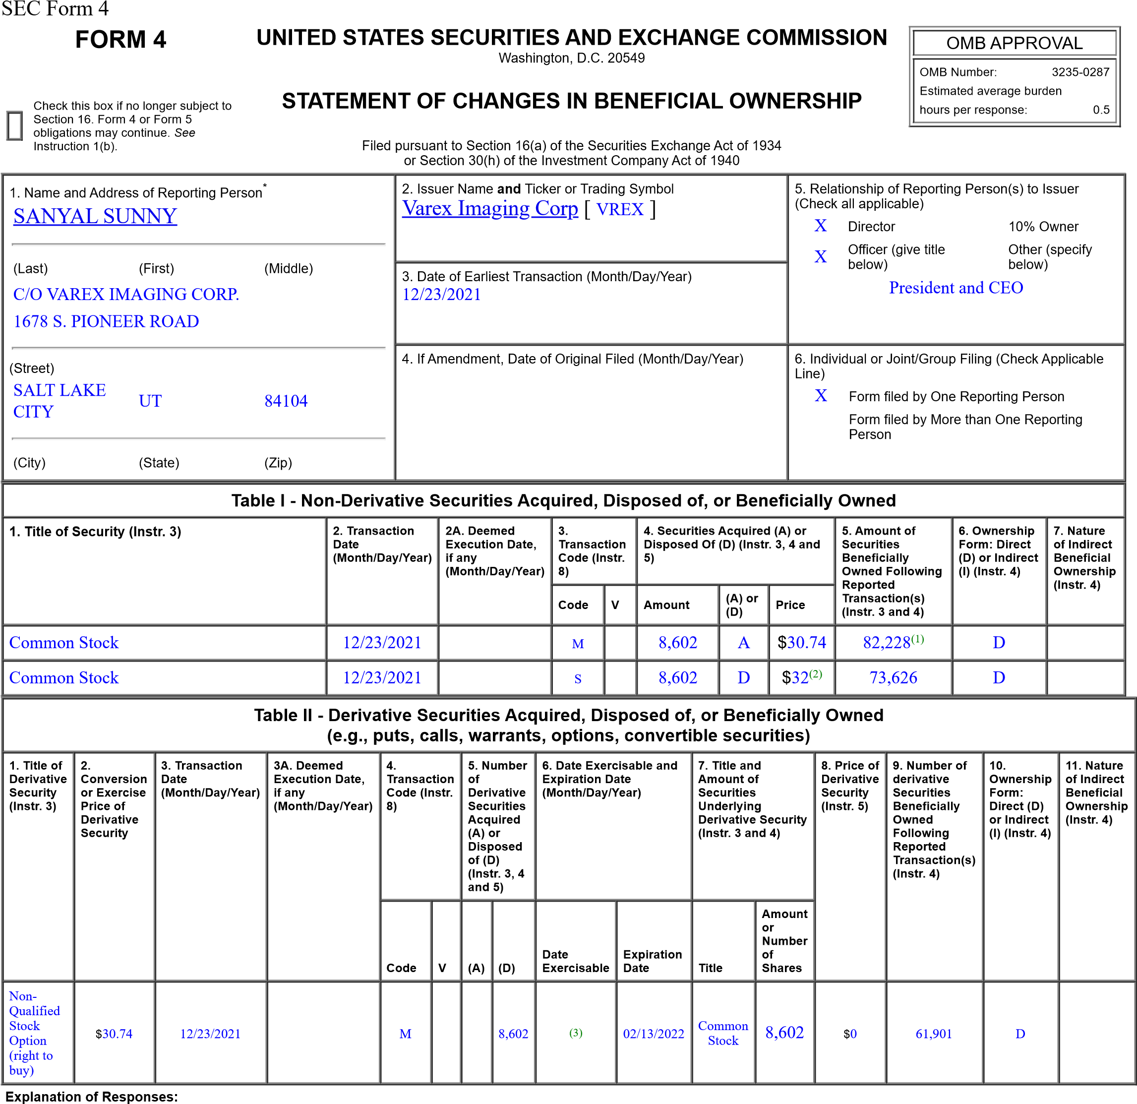
- Amount of securities beneficially owned at end of reporting period reflect 2,945 shares purchased under the Varex Imaging Corporation 2017 Employee Stock Purchase Plan.
- The sales reported in this Form 4 were effected pursuant to a 10b5-1 trading plan adopted by the reporting person on March 16, 2021. The price reported in column 4 is a weighted average price. Theseshares were sold in multiple transactions at prices ranging from $32.00 to $32.03. The reporting person undertakes to provide Varex Imaging Corporation, any security holder of Varex Imaging Corporation or the staff of the Securities and Exchange Commission, upon request, full information regarding the number of shares purchased at each separate price within the range set forth in this footnote.
- The non-qualified stock options were subject to a three-year vesting period. One-third vested on February 13, 2016, and the remaining two-thirds vested on a pro-rata basis monthly thereafter.
Remarks:
/s/ Sunny Sanyal 12/27/2021
** Signature of Reporting Person Date Reminder: Report on a separate line for each class of securities beneficially owned directly or indirectly.
* If the form is filed by more than one reporting person, see Instruction 4 (b)(v).
** Intentional misstatements or omissions of facts constitute Federal Criminal Violations See 18 U.S.C. 1001 and 15 U.S.C. 78ff(a).
Note: File three copies of this Form, one of which must be manually signed. If space is insufficient, see Instruction 6 for procedure.
Persons who respond to the collection of information contained in this form are not required to respond unless the form displays a currently valid OMB Number.

