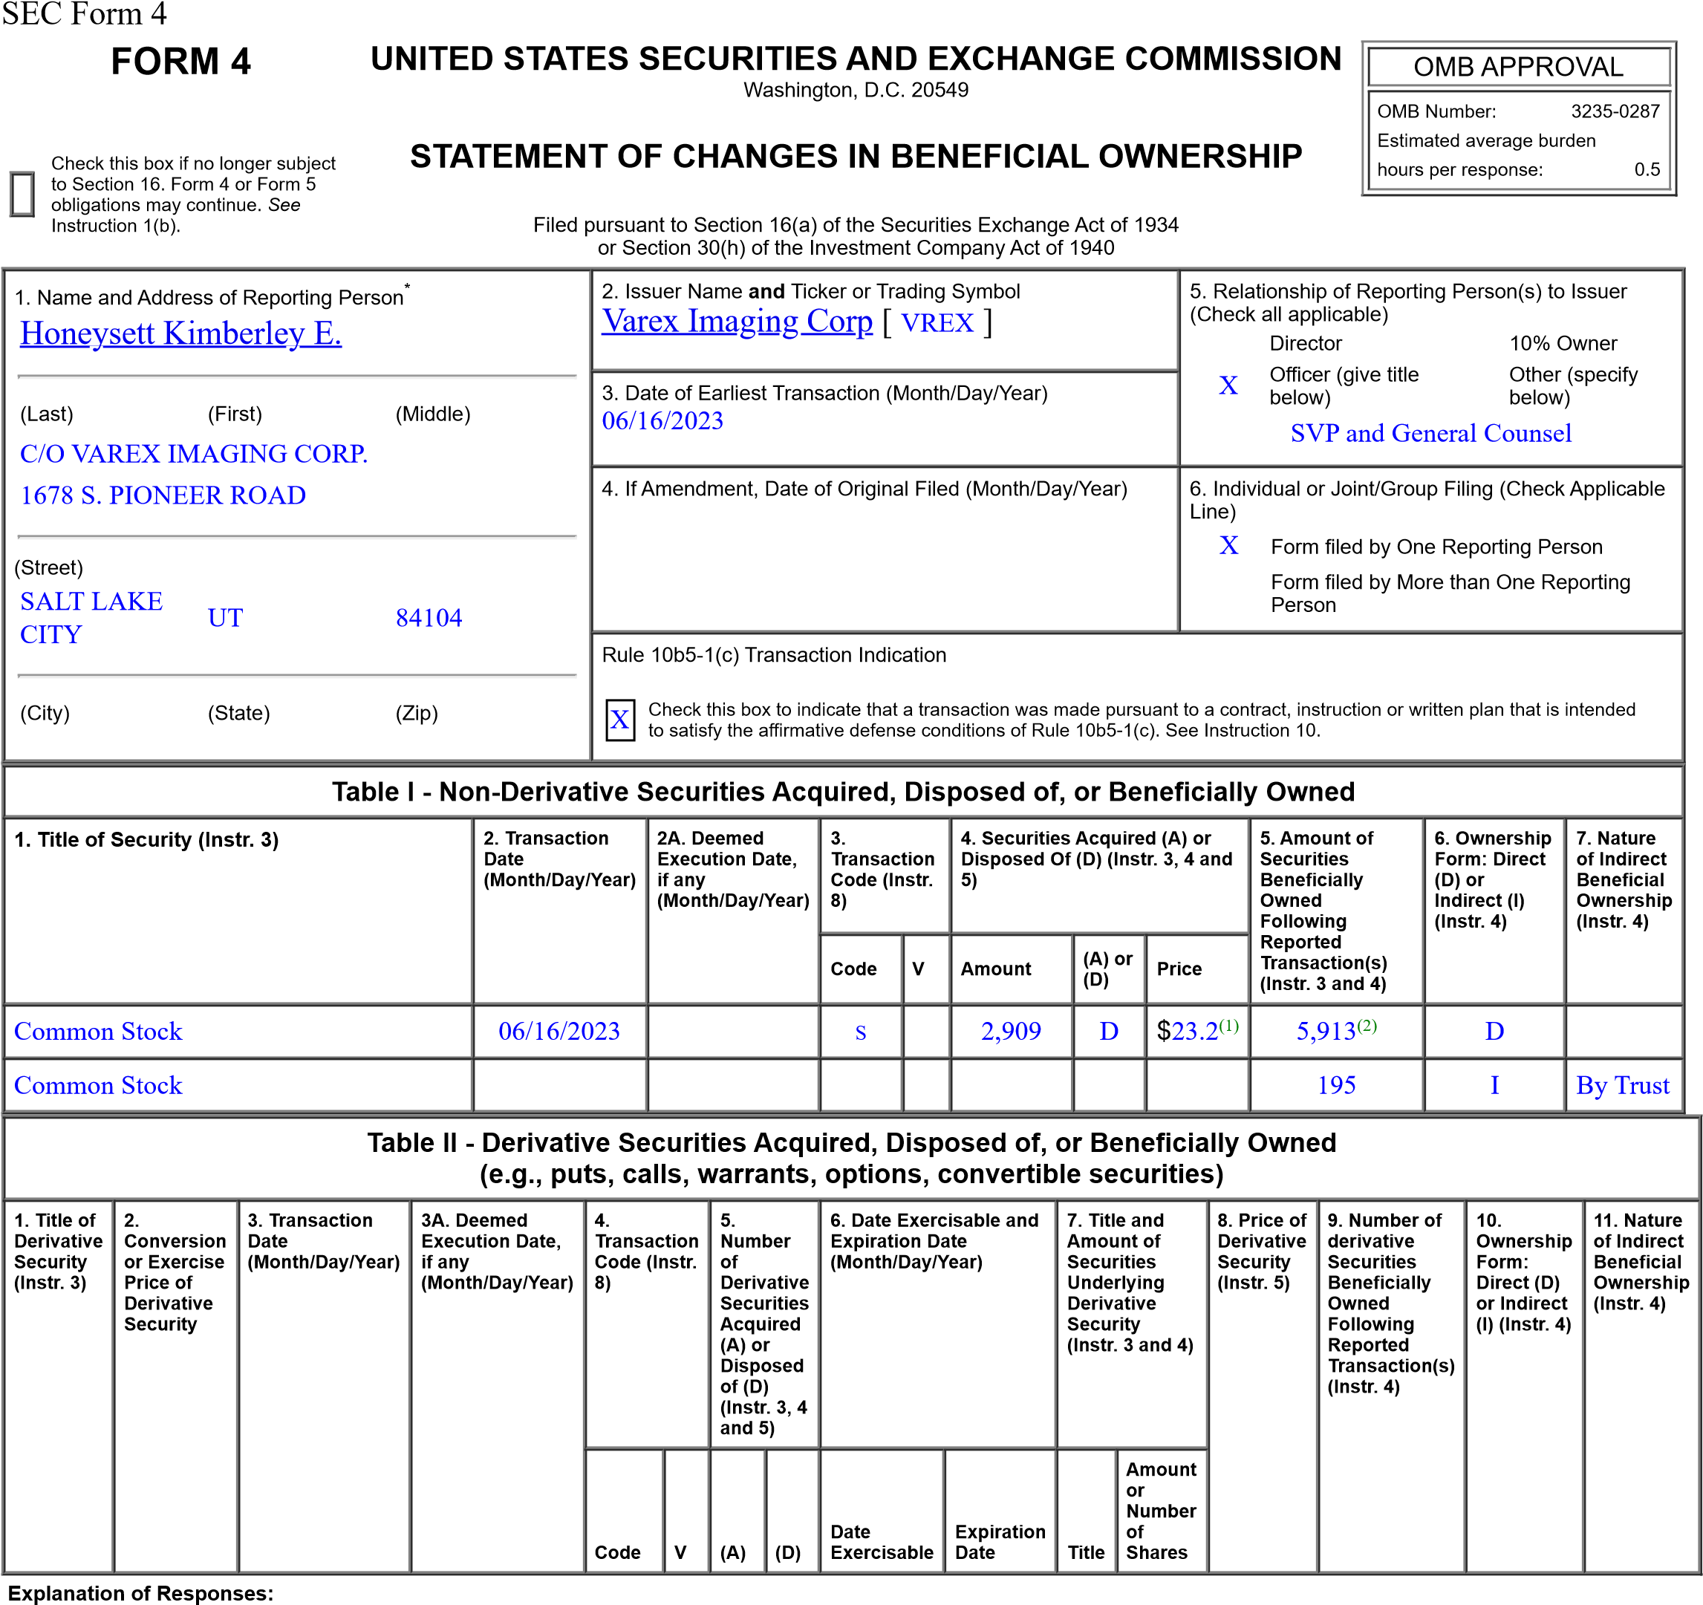
- The sales reported in this Form 4 were effected pursuant to a 10b5-1 trading plan adopted by the reporting person on Mar 17, 2023. All shares were sold at $23.20
- Amount of securities beneficially owned at end of reporting period reflect 252 shares purchased under the Varex Imaging Corporation 2017 Employee Stock Purchase Plan since the last Form 4 filingof the reporting person.
Remarks:
/s/ Kimberley E. Honeysett 06/19/2023
** Signature of Reporting Person Date Reminder: Report on a separate line for each class of securities beneficially owned directly or indirectly.
* If the form is filed by more than one reporting person, see Instruction 4 (b)(v).
** Intentional misstatements or omissions of facts constitute Federal Criminal Violations See 18 U.S.C. 1001 and 15 U.S.C. 78ff(a).
Note: File three copies of this Form, one of which must be manually signed. If space is insufficient, see Instruction 6 for procedure.
Persons who respond to the collection of information contained in this form are not required to respond unless the form displays a currently valid OMB Number.

