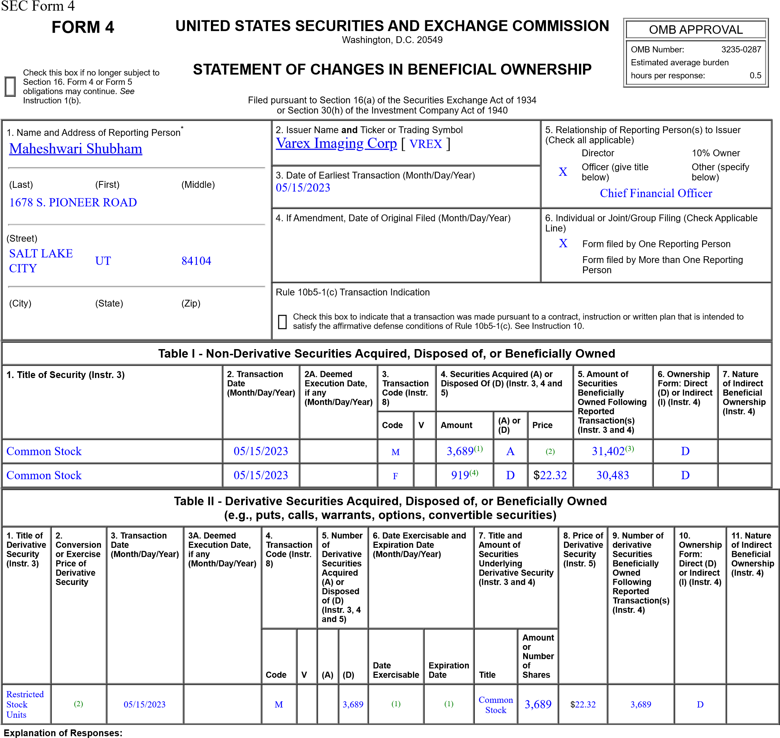
- On May 21, 2021, the Reporting Person was granted 7,378 Restricted Stock Units, 50% of which vested on May 15, 2023 and 50% of which vest on May 15, 2025.
- Each Restricted Stock Unit converts into common stock on a one-for-one basis.
- Amount of securities beneficially owned at the end of the reporting period reflects 1,173 shares purchased under the Varex Imaging Corporation 2017 Employee Stock Purchase Plan.
- These shares represent shares withheld for satisfaction of a tax withholding obligation arising as a result of the vesting of the Restricted Stock Units reported herein.
Remarks:
/s/ Kimberley Honeysett,
attorney-in-fact for Shubham 05/17/2023 Maheshwari
** Signature of Reporting Person Date Reminder: Report on a separate line for each class of securities beneficially owned directly or indirectly.
* If the form is filed by more than one reporting person, see Instruction 4 (b)(v).
** Intentional misstatements or omissions of facts constitute Federal Criminal Violations See 18 U.S.C. 1001 and 15 U.S.C. 78ff(a).
Note: File three copies of this Form, one of which must be manually signed. If space is insufficient, see Instruction 6 for procedure.
Persons who respond to the collection of information contained in this form are not required to respond unless the form displays a currently valid OMB Number.

