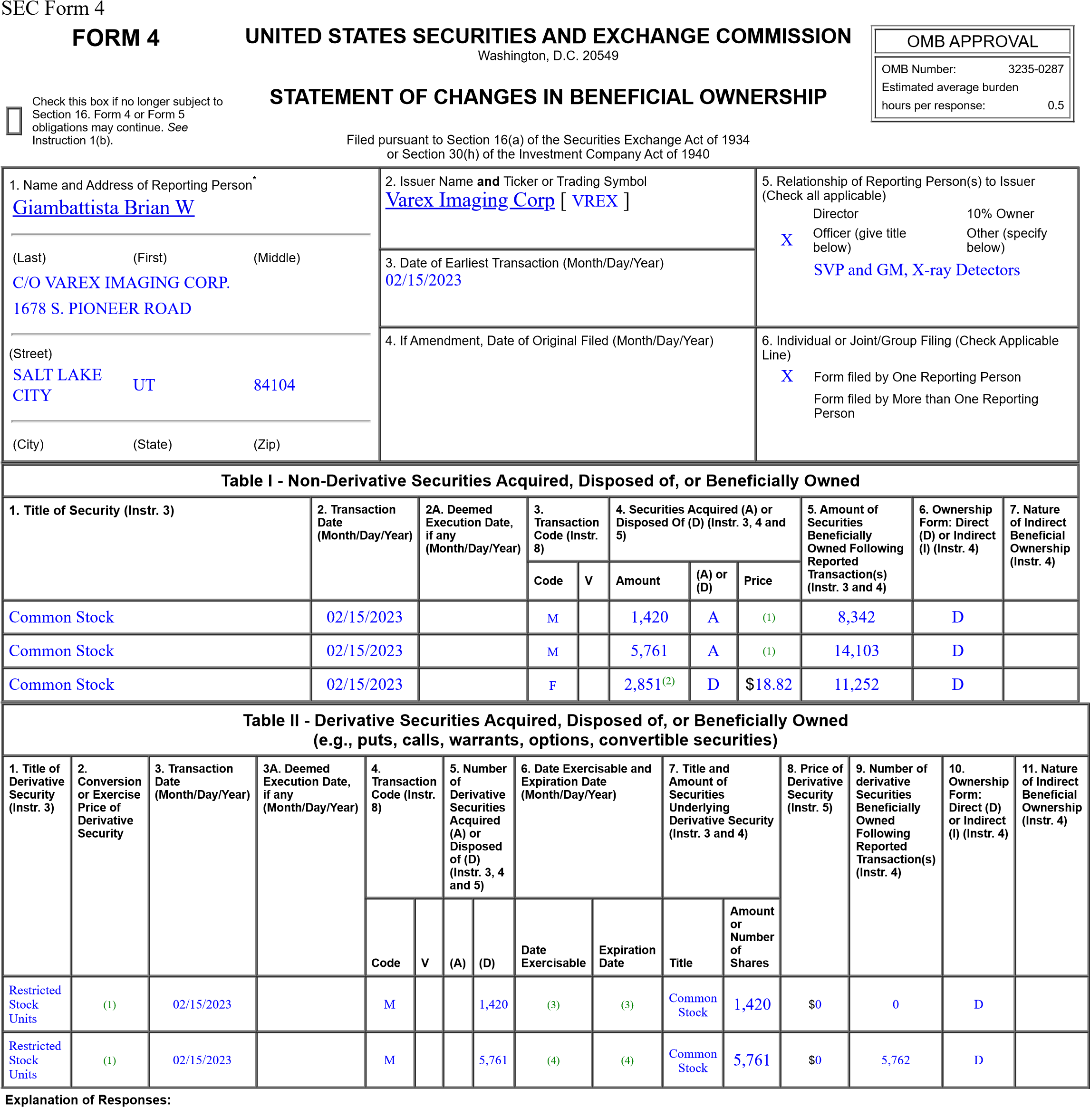
- Each Restricted Stock Unit converts into common stock on a one-for-one basis.
- These shares represent shares withheld for satisfaction of a tax withholding obligation arising as a result of the vesting of the Restricted Stock Units reported herein.
- The Restricted Stock Units granted on February 15, 2019 vest 25% each year for four years beginning on February 15, 2020. Vested shares will be delivered to the reporting person upon vest date.
- These Restricted Stock Units granted on February 16, 2021 vest 50% on February 15, 2023 and 50% on February 15, 2025. Vested shares will be delivered to the reporting person upon vest date.
Remarks:
/s/ Brian W Giambattista 02/16/2023
** Signature of Reporting Person Date Reminder: Report on a separate line for each class of securities beneficially owned directly or indirectly.
* If the form is filed by more than one reporting person, see Instruction 4 (b)(v).
** Intentional misstatements or omissions of facts constitute Federal Criminal Violations See 18 U.S.C. 1001 and 15 U.S.C. 78ff(a).
Note: File three copies of this Form, one of which must be manually signed. If space is insufficient, see Instruction 6 for procedure.
Persons who respond to the collection of information contained in this form are not required to respond unless the form displays a currently valid OMB Number.

