DEFA14A 1 tm2225010d2_defa14a.htm DEFA14A

UNITED STATES
SECURITIES AND EXCHANGE COMMISSION
Washington, D.C. 20549

SCHEDULE 14A
Proxy Statement Pursuant to Section 14(a) of
the Securities Exchange Act of 1934 (Amendment No. )

Filed by the Registrant 
Filed by a Party other than the Registrant □
Check the appropriate box:
- Preliminary Proxy Statement
- Confidential, for Use of the Commission Only (as permitted by Rule 14a-6(e)(2))
- Definitive Proxy Statement
 Definitive Additional Materials
- Soliciting Material under §240.14a-12

VAREX IMAGING CORPORATION
(Name of Registrant as Specified In Its Charter)
(Name of Person(s) Filing Proxy Statement, if other than the Registrant) Payment of Filing Fee (Check the appropriate box):
 No fee required.
- Fee paid previously with preliminary materials.
- Fee computed on table in exhibit required by Item 25(b) per Exchange Act Rules 14a-6(i)(1) and 0-11

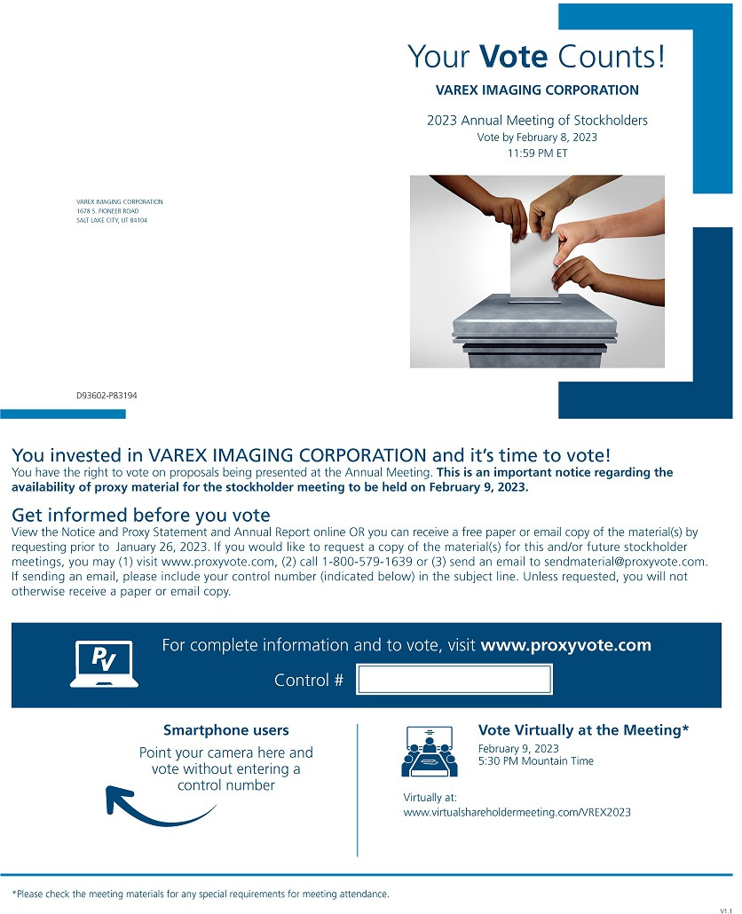

Your Vote Counts! VAREX IMAGING CORPORATION2023 Annual Meeting of Stockholders Vote by February 8, 2023 11:59 PM ETVAREX IMAGING CORPORATION 1678 S. PIONEER ROAD SALT LAKE CITY, UT 84104D93602-P83194You invested in VAREX IMAGING CORPORATION and it’s time to vote! You have the right to vote on proposals being presented at the Annual Meeting. This is an important notice regarding the availability of proxy material for the stockholder meeting to be held on February 9, 2023. Get informed before you vote View the Notice and Proxy Statement and Annual Report online OR you can receive a free paper or email copy of the material(s) by requesting prior to January 26, 2023. If you would like to request a copy of the material(s) for this and/or future stockholder meetings, you may (1) visit www.proxyvote.com, (2) call 1-800-579-1639 or (3) send an email to sendmaterial@proxyvote.com. If sending an email, please include your control number (indicated below) in the subject line. Unless requested, you will not otherwise receive a paper or email copy.For complete information and to vote, visit www.proxyvote.com Control #Smartphone users Point your camera here and vote without entering a control numberVirtually at:Vote Virtually at the Meeting* February 9, 2023 5:30 PM Mountain Timewww.virtualshareholdermeeting.com/VREX2023*Please check the meeting materials for any special requirements for meeting attendance.V1.1

Vote at www.proxyvote.com

THIS 15 NOT A VOTABLE BALLOT
This i; an overvi@w of Lhe proposals being prnsent@d at Lhe upcoming stockholder meeting, Please follow the instructions on the reverse side to vote these important matters.

Voting Items
- To elect s,even directors to serve until the 2024 Annual Meeting of Stockholders.
Nominees:
1a. Kathleen L. Bardwell
1b. Jocelyn D. Chertoff, M.D.
1c. Timothy i:::_ Guertin 1d. Jay K. Kunkel
1e Walter M Rosebrough, Jr_ 1f. Sunny S. Sanyal
Board
Recommends

$For
$For C)For C)For C,For C,For

1g. Christine A Tsingos C, For

To .;pprove, on an advi$Ory basis, our exetutive compensation as described in the eH'.tompanyin-g Proxy Statement. C, For
- o ratify the appointment of Deloitte & Touche LLP' as our independent registered public accounting firm for fiscal year 2023. 0 For
NOiTIE: The proxyholdersare authorized to vote on any other business as is properly brought before the Annual Meeting for action in accordance with their judgment as to the best interests of Varex Imaging Corporation.

Prefer to receive an email instead? While voting on www.proxyvote.com, be sure to dick "Sign up for E-delivery".

D',1360;1-Pi,31S,J

Vote at www.proxyvote.comTHIS IS NOT A VOTABLE BALLOT This is an overview of the proposals being presented at the upcoming stockholder meeting. Please follow the instructions on the reverse side to vote these important matters.Voting Items 1. To elect seven directors to serve until the 2024 Annual Meeting of Stockholders. Nominees: 1a. Kathleen L. Bardwell 1b. Jocelyn D. Chertoff, M.D. 1c. Timothy E. Guertin 1d. Jay K. Kunkel 1e. Walter M Rosebrough, Jr. 1f. Sunny S. Sanyal 1g. Christine A. Tsingos 2. To approve, on an advisory basis, our executive compensation as described in the accompanying Proxy Statement. 3. To ratify the appointment of Deloitte & Touche LLP as our independent registered public accounting firm for fiscal year 2023. NOTE: The proxyholders are authorized to vote on any other business as is properly brought before the Annual Meeting for action in accordance with their judgment as to the best interests of Varex Imaging Corporation.Board RecommendsFor For For For For For For For ForPrefer to receive an email instead? While voting on www.proxyvote.com, be sure to click “Sign up for E-delivery”.D93603-P83194

