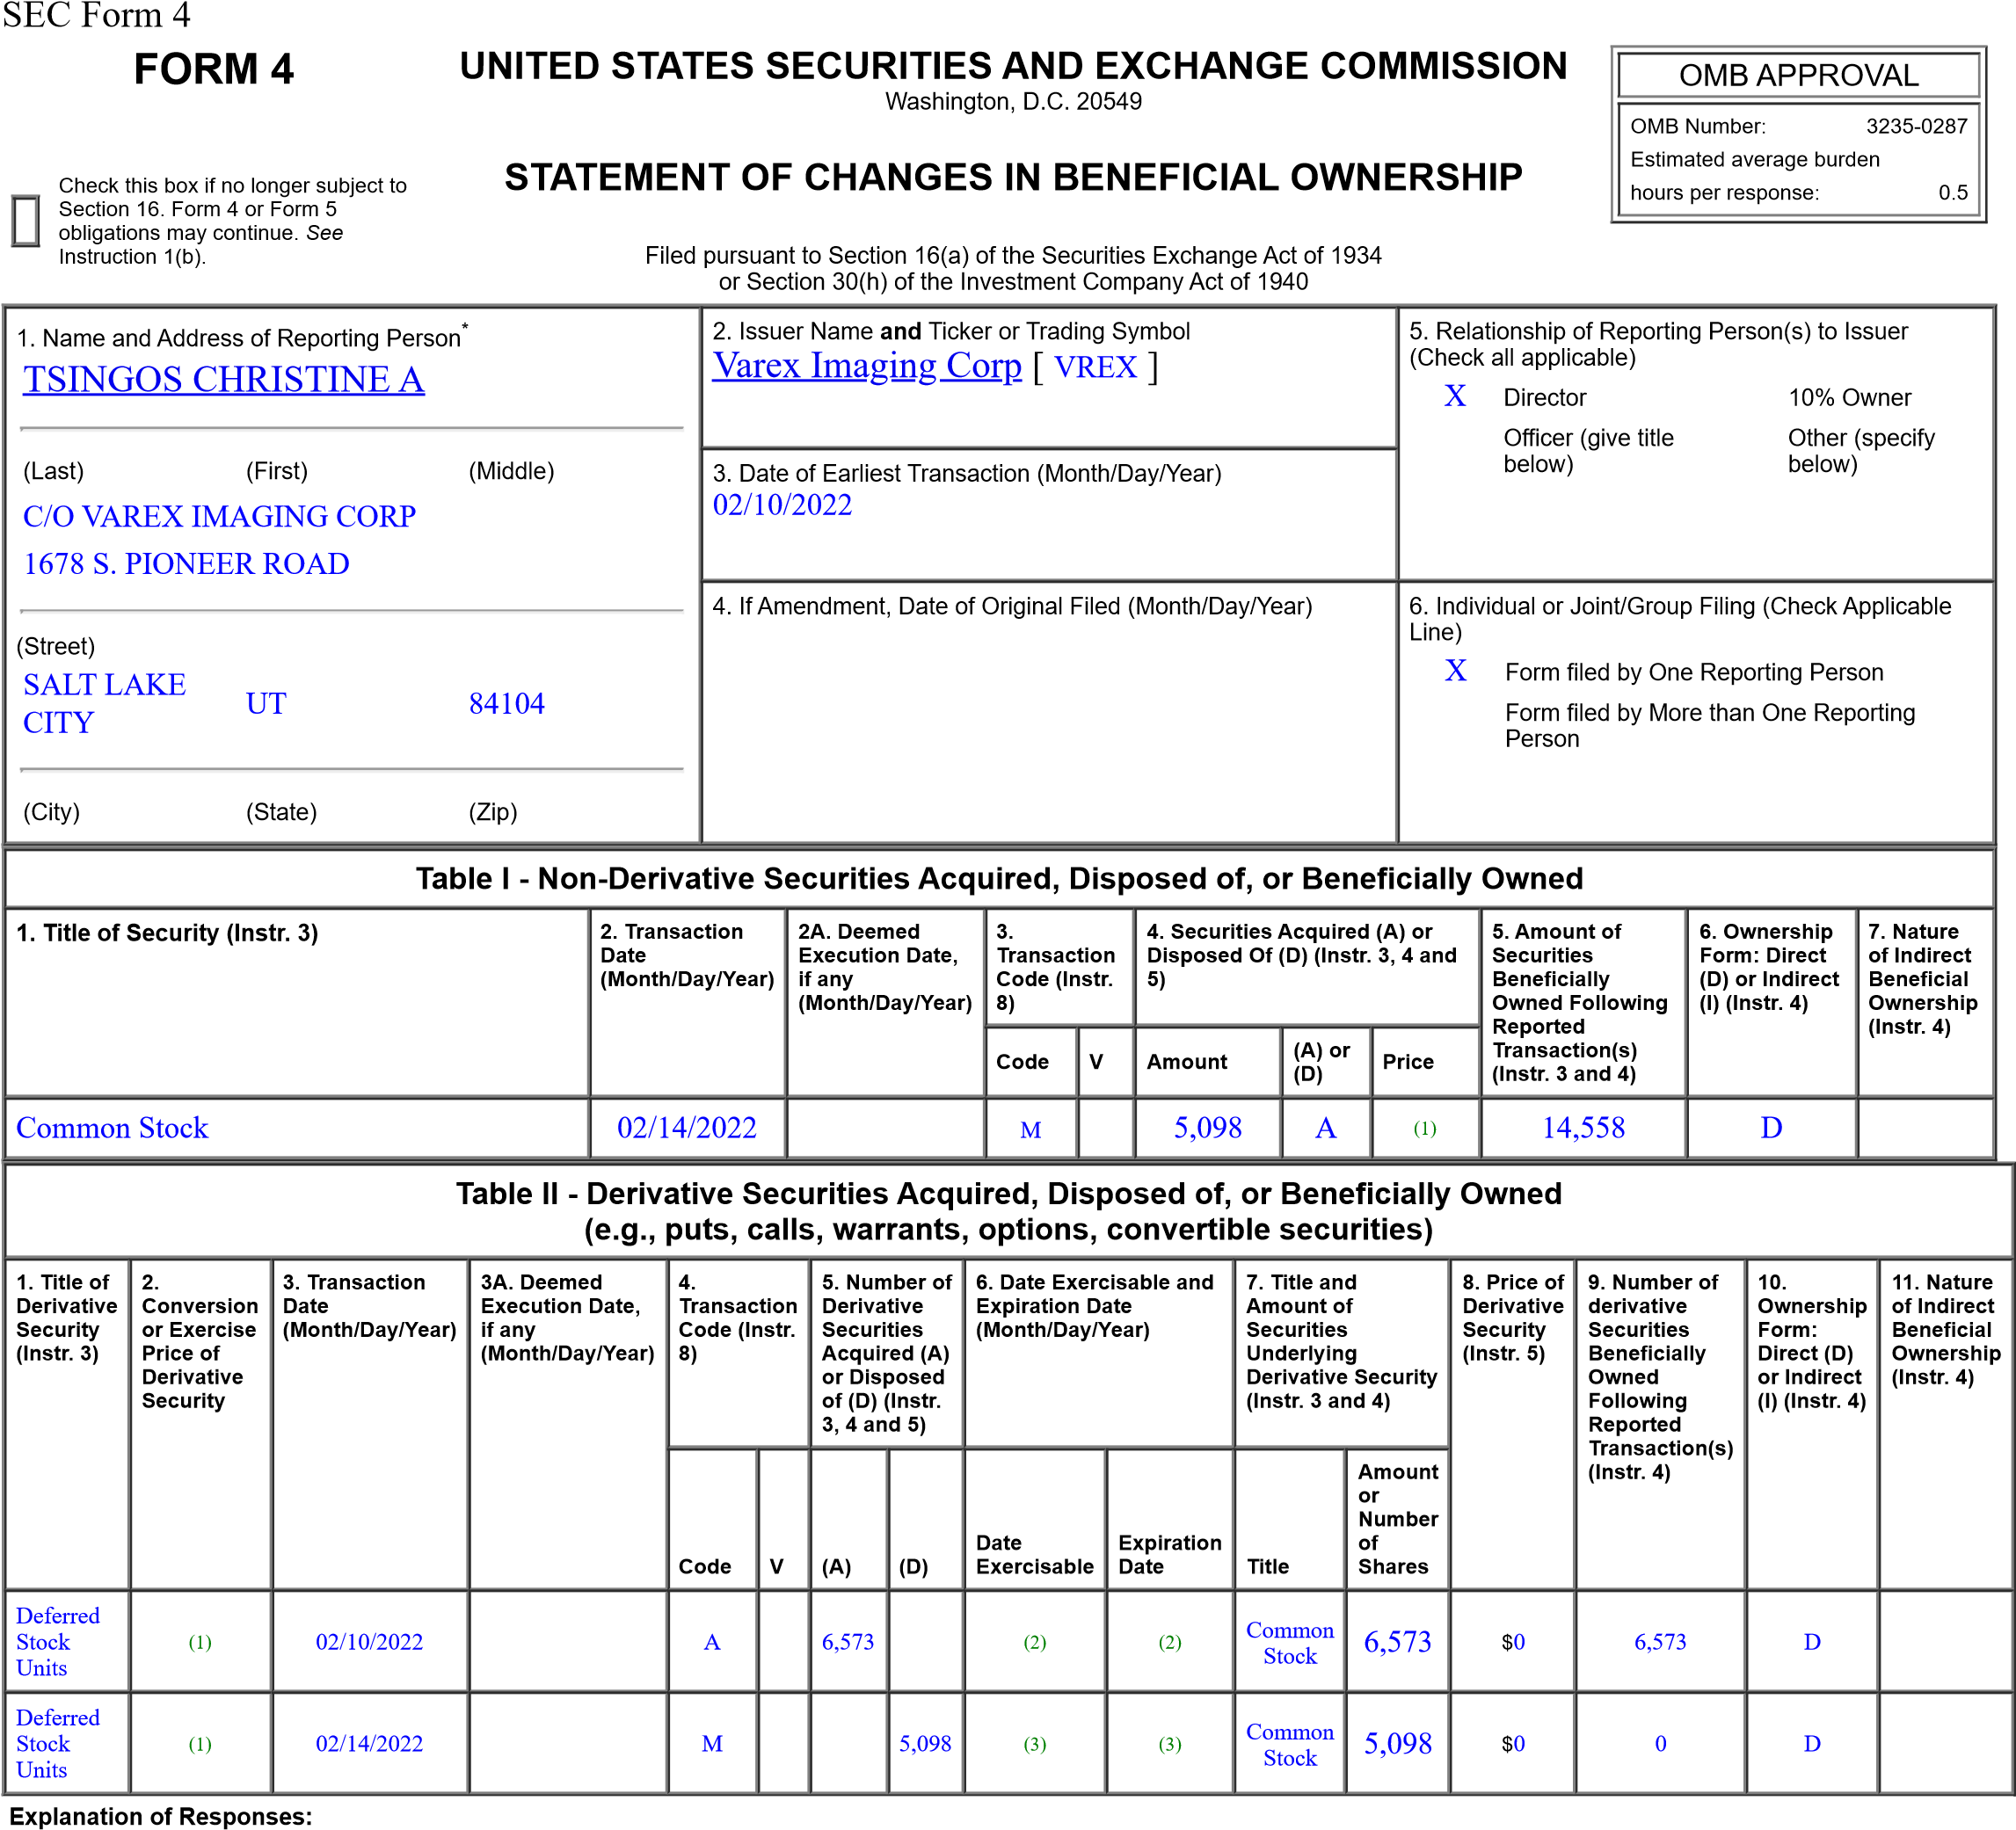
- Each Deferred Stock Unit converts into common stock on a one-for-one basis.
- These Deferred Stock Units vest 100% on the earlier of (i) the one-year anniversary of the date of the grant and (ii) the date of the first annual meeting following the date of grant. Vested shares will bedelivered to the reporting person upon the earlier of (i) 2025 Annual Meeting (ii) a change in control or (iii) the reporting person's termination of service for any reason.
- These Deferred Stock Units vested on February 14, 2020. Pursuant to the terms of the applicable grant agreement, delivery of the vested Deferred Stock Units, in the form of common stock, was made onFebruary 14, 2022.
Remarks:
/s/ Kimberley Honeysett
02/14/2022
attorney-in-fact
** Signature of Reporting Person Date Reminder: Report on a separate line for each class of securities beneficially owned directly or indirectly.
* If the form is filed by more than one reporting person, see Instruction 4 (b)(v).
** Intentional misstatements or omissions of facts constitute Federal Criminal Violations See 18 U.S.C. 1001 and 15 U.S.C. 78ff(a).
Note: File three copies of this Form, one of which must be manually signed. If space is insufficient, see Instruction 6 for procedure.
Persons who respond to the collection of information contained in this form are not required to respond unless the form displays a currently valid OMB Number.

